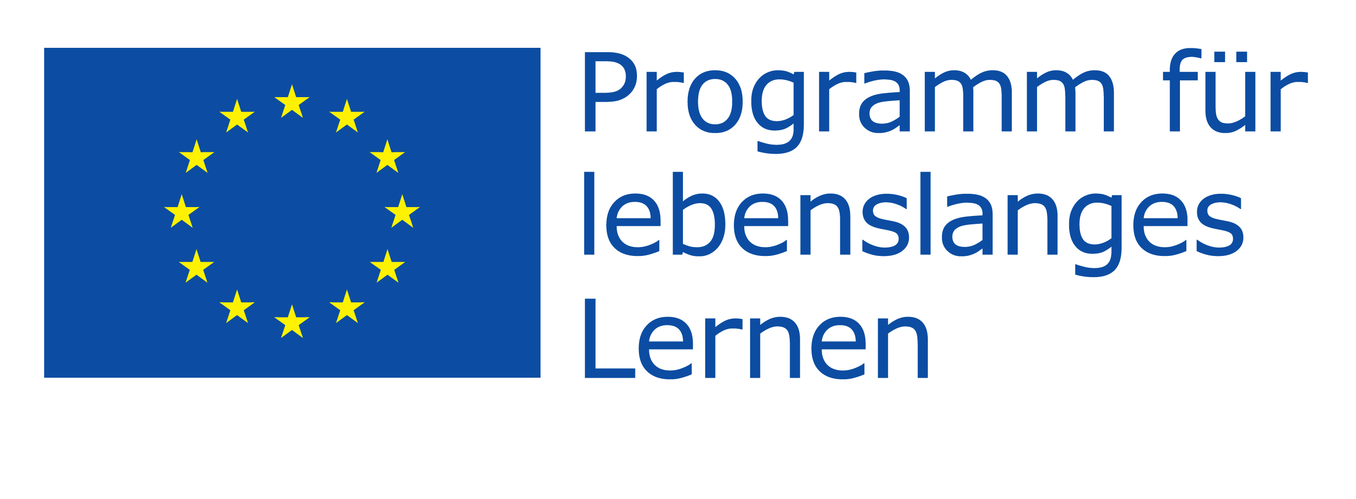 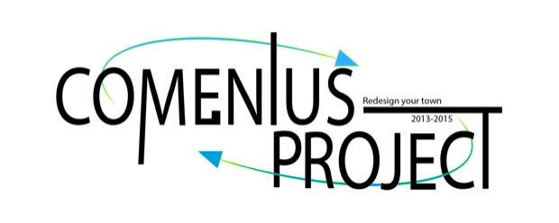

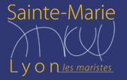 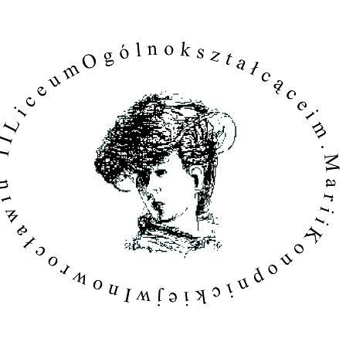  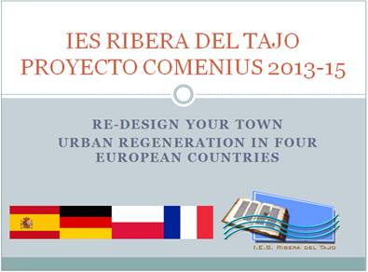

Thursday, 2015-01-08 Arrival of the international teams at Düsseldorf Airport   
Polish team at 18:35 (German Wings)  
Spanish team at 18:20 (Iberia express)  
French team at 21:50 (German Wings)  
We will pick you up at the airport.

Friday, 2015-01-09 10:30 Reception in the town hall by the Lord Mayor  
 (Rathaus Abtei in Mönchengladbach)

12:30 Lunch at school14:00 Ice breakers  
16:00 First workshop session with the actress Eva Spott  
17:30 Going ice skating at Grefrath (by coach)   
 Stadionstr. 161 · 47929 Grefrath  
The families will pick you up at the school at 22:00.

Saturday, 2015-01-10 09:30 TRIP TO COLOGNE (by coach from Vossenbäumchen)  
- visit of Cathedral for all  
- Museum Ludwig – POP ART  
- Sport Museum  
- Walk and Tower

19:00 back at school

Sunday, 2015-01-11 11:00 Second workshop session at school (with Eva Spott)  
13:00 lunch at school14:00 Third Workshop (4 national groups)  
17:00 Return to the families  
Free time

Monday, 2015-01-12 09:00 Meeting at Schloss Rheydt (Rheydt Palace), Schloßstr. 508   
 Preparing the presentation / technical rehearsal  
12:00 Lunch at the Purino Restaurant nearby  
13:00 Presentation of the groups’ work in front of the jury:  
Eva Spott: Oral presentation  
Ralf Eggen: Media design  
Prof. Nico Beucker: Concept   
Ulrich Elsen: Added value to the urban community  
15:30 Presentation of the awards by the jury  
16:00 Free time  
19:00 Farewell Party at school (home-made buffet)

Tuesday, 2015-01-13 Spanish team will leave at 07:55  
Polish team and French team will attend classes at school  
Departure of both teams at 18:35

Contact in case of any emergency (!): The guest students should contact their teachers.  
00491608071050 (Mrs. Vollmer) or 00491708378343 (Mrs. Kölling)  
00492161-6881666 (Mr. Weinberg)

**PROGRAM: COMENIUS-PROJECT**

**Redesign your town**

**Gesamtschule Hardt, 41169 Mönchengladbach, Vossenbäumchen 50**